**Title:**

NAND LED Circuit

**Date:**

20/NOV/2018

**Aim:**

The aim of the experiment is to light up the LED in the circuit using a 7400 Quad 2-input NAND, 8-Way switches and to get used to using the inputs and outputs of a circuit.

**Analysis:**

I expected to get a truth table of a NAND gate, (Shown below).

|  |  |  |
| --- | --- | --- |
| **Input** |  | **Output** |
| **A** | **B** | **out** |
| 0 | 0 | 1 |
| 0 | 1 | 1 |
| 1 | 0 | 1 |
| 1 | 1 | 0 |

**NAND GATE:**

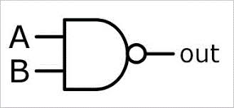

**Logic Diagram:**

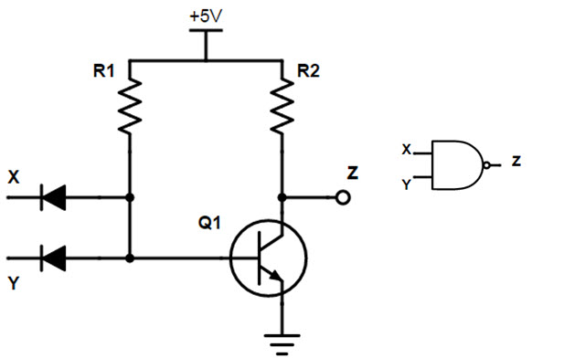

The logic behind the NAND gate is that if both A and B are on, then the output would be off. Otherwise, the output would be on.

**Results:**

From our lab session we got the following results which matched that of the NAND gate truth table which told us that our results were correct.

|  |  |  |
| --- | --- | --- |
| **Input** |  | **Output** |
| **A** | **B** | **out** |
| 0 | 0 | 1 |
| 0 | 1 | 1 |
| 1 | 0 | 1 |
| 1 | 1 | 0 |

**Conclusion:**

In conclusion, the truth table from our analysis of the circuit diagram matched that of our results. The NAND gate allows current to pass when the inputs are (0,0), (0,1), (1,0). That means that if the LED is off, then the inputs are both on.